A000-Afr-Mali-Bamana-Tji Warra-Tyiwarra-Chi Wara-Ci Wara- Statue - Male

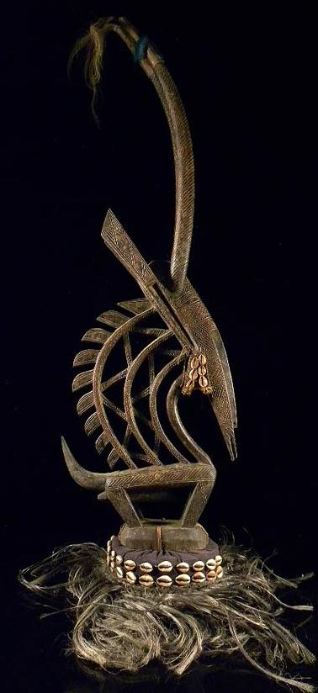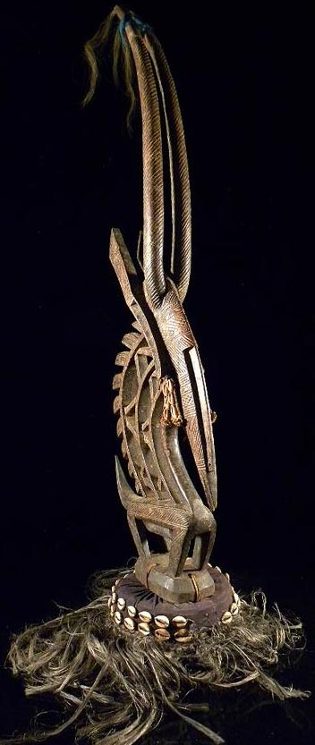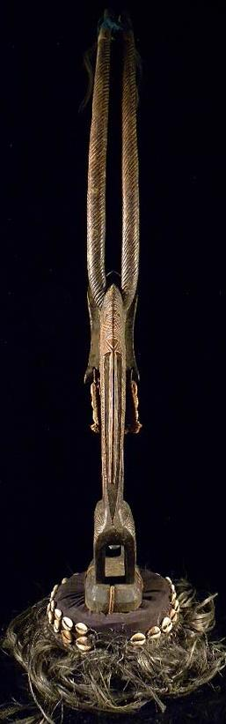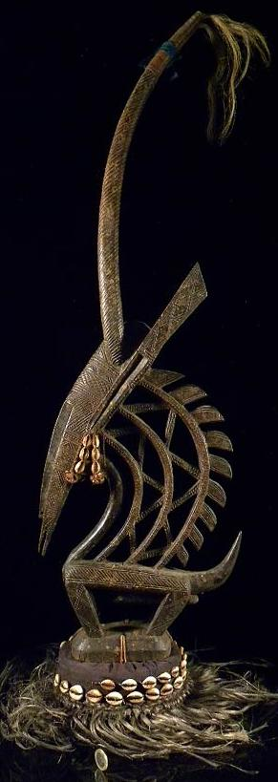

Case no. 6

Male Tji Warra headdress, Mali, Bamana peoples Baninko region, 19th-20th century, 39 in., 99 cm., 2 kg, wood., cowrie shells, hair, fiber. This example of a Tji Warra exemplifies the vertical style as one of the three distinctive sculptural Bamana styles that emulates the form of the mythical antelope in both its male and female aspects, of which this represents the male (Zahan 1980). The body and legs are minimized while the neck, mane, head, and elongated horns are emphasized. "The result is a form, abstract yet precise in detail, that suggests the bounding life of the original model restrained by an extraordinary dignity" (Goldwater 1960: 16).

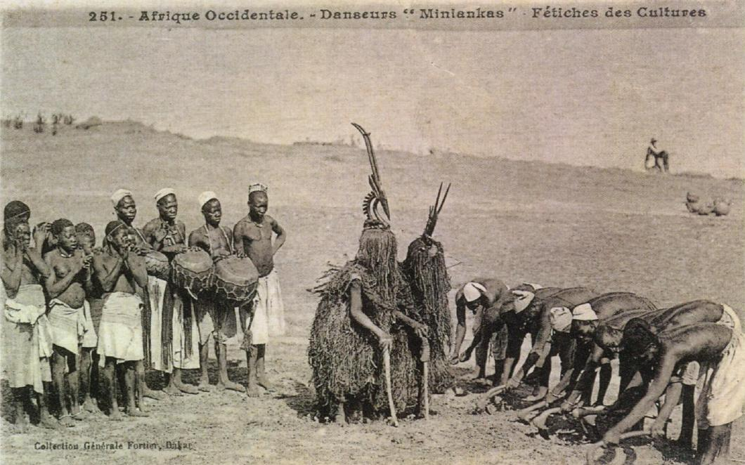

Fig. Collection Générale Fortier, Dakar. [No.] 251. Afrique Occidentale.-Danseurs "miniakas" Fétiches des Cultures, *ca.* early 1900's.

Bamana *Tji Warra* headdresses once fea­tured prominently in local agricultural, mythic masquerades of the origin of agriculture. Originally these mythic masquerades were performed on fields during the labor-intensive process of cultivating the land in preparation for planting. Male and female *Tji Warra* forms relate to the sacred origins of fructification both of the agricul­tural field and the woman's body (Imperato 1970; Zahan 1980; Colleyn 2001; LaGamma 2002). The *Tji Warra* masked personae performed their masquerade on fields later farmed by forced labor, but the earlier origins are important for understanding the human-animal analogy. The Bamana mythology of creation invokes Tji Warra as a therianthropic spirit half-human and half-antelope that sacri­ficed itself in protesting human wantoness in the control of the land (women) and its productive use. The human counterpart to this is not hard to see. The land which is being furrowed is like the womanly body being prepared for human procreation. The Tji Warra dancer is guided into an obsequious bending posture emulating both an antelope (with two meter-long sticks for its forelegs) and obeisant farmers in the field (and husbands in the home). Sexual imagery in the headdress is manifest in the shape not only of the stylized antelope's head, mane and horns but also in the similarity to the traditional form of the short-handled agricultural hoe, suggesting that the antelope's wisdom is to communicate how to engender fertility. The merger of farmer and antelope is complete.

Bound to the costume's forelegs are *boliw,* or objects which are mystical sources of power. These portable altars are used in ritual sacrifice and are made from a wide range of materials (wood, bark, stones, roots, hair, animal tails, claws, teeth, blood, human bones). In order to be energized the boliw must regularly receive blood from sacrifices in order to call upon and influence the life force known as Nyama. This life force is the same that bound the Bamana people to the authority of its king. The male and female *Tji Warra* paired masked performers are themselves tied together by *boliw:* to walk between the two is said to bring grave harm. The two bent-over *Tji Warra* performers recall the rows of laborers laboring side by side under the authority of their overlords. This at­tribute of servitude is reinforced visually by the *Tji Warra* costumes, whose mud-caked fibers make these farmer-performers visu­ally synonymous with the soil they are obliged to farm.

*Tji Warra* headdresses symbolize roan antelopes *(Hippotragus equi­nus* with their heads, horns, raffia fiber costumes, and quadruped stick "legs". The male *Tji Warra* costume is that of a wild game animal, the quarry of a Bamana hunter. In the period of the Bamana empire, those men famed for their hunting skills served as warriors in the Bamana army in which they hunted youth from distant areas to serve as slaves on state farms in order to fulfill the needs of the colonial slave trade to which the Bamana empire was a key supplier (Djata 1997).

The headdresses follow animal behavior and ethology whenever possible. The female antelope's horns are more spear-like, capable of impaling an enemy in the act of offensively protecting her offspring. On the other hand, the male antelope's horns curve backward so that rutting fights over female antelopes would be less deadly. Male antelope symbolism emphasizes sexual prowess, emphasized by his bristling mane invoking a sense of awe in his opponents. The female *Tji Warra* head­dress indicates that the female carries her offspring (in this case another female) on her back. This position of carrying her baby on her back has no basis in the roan antelope's behavior: it is used to reinforce the correct Bamana mother's position of carrying her baby. This suggests that the Bamana human mother and husband are paradigms embodying animal ethology and behavior (which the Bamana paid such close attention to in both daily and mythic life) but departting from it when it was a matter of the need to reinforce ancient Bamana traditions.

Blier, Suzanne Preston.2004. African Creation Myths as Political Strategy, *African Arts,* 37(1), Explorations of Origins (Spring), pp. 38-45+94.

Colleyn, Jean-Paul. 2001. "The Power Associations: The Ci­wara," in *Bamana: The Art of Existence in Mali,* ed. Jean-Paul Colleyn, pp. 200-234. Exhibition catalogue. New York: The Museum for African Art.

Djata, Sundiata A. 1997. *The Bambara Empire by the Niger: King­dom, Jihad and Colonization 1712-1920.* Princeton, NJ: Markus Weiner.

Goldwater, Robert. 1960. *Bambara sculpture from western Sudan*. New York: Museum of Primitive Art.

Imperato, Pascal James. 1970. "The Dance of the Tyi Wara," *African Arts* 4,1:8-13, 71-80.

LaGamma, Alisa. 2002. *Genesis: Ideas of Origin in African Sculp­ture.* New York: Metropolitan Museum of Art and New Haven: Yale University Press.

Zahan, Dominique. 1980 *Antilopes du soleil: artes et rites d'Afrique du noire*. Vienna: A Schendl.

